Wisper logo no flag

**Owner’s Manual**

**Wisper 806SE 2017 Model**

May 2017 2nd edition

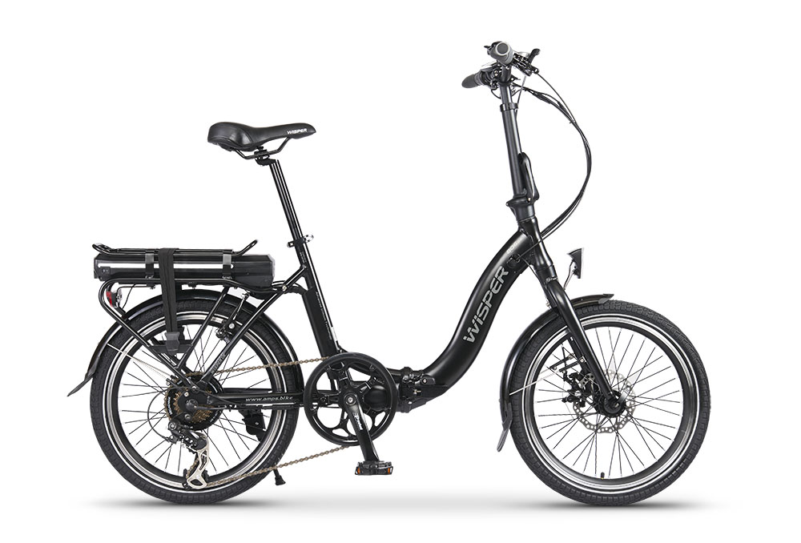

**We strongly recommend that you read this entire manual before using your Wisper bike**

Contents

1 **Introduction 3**

2 **Caring for your Wisper bike and pre-use checks 4**

2.1 Before you set off for the first time

2.2 Before each use

2.3 Battery care

2.4 Recharging your battery

2.5 Water

2.6 Maintenance and adjustments

2.7 Technical specifications & performance

2.8 Simple Trouble shooting

3 **Controls and equipment 12**

3.1 Battery on/off switch and lock

3.2 The ON/OFF button and Light button

3.3 The Throttle

3.4 Torque sensor

3.5 Battery capacity meter, riding style and affect on range

3.6 Brakes

3.7 Stem and handle bar clamps

3.8 Folding mechanisms

3.9 The connectors

3.10 Quick release saddle height adjustment

3.11 Rims and spokes

3.12 Chain and drive wheel removal

3.13 Derailleur and gear change

4 **Warranty, battery maintenance and user responsibilities 22**

4.1 Battery maintenance and user responsibilities

5 **Service 24**

6 **Pre Delivery Inspection check list 25**

# Introduction

Thank you for choosing a Wisper electric bicycle.

Before you use your Wisper electric bike it is important that you read this manual carefully. If there is anything you do not understand completely, please contact us.

Please observe traffic regulations, and do not lend your bicycle to anyone who is unfamiliar with it. In the UK the bicycle can only legally be used on the road by a person aged fourteen years or older.

We strongly advise you to always wear an approved cycle helmet when riding your bicycle. If you are unfamiliar with cycling, we advise attending a cycle proficiency course prior to using your new bicycle on the public highway.

When using any bicycle, it is important that you stay within safe limits; if you feel as if you are travelling too quickly, you probably are.

Always test your brakes prior to using the bike, and remember the bike will not stop as quickly in the wet as it would in the dry!

Before you use the bike for the first time, please make absolutely certain that it has been correctly assembled. You can do this by either taking it to your nearest cycle engineer or if you are proficient in cycle mechanics, inspecting it yourself. In particular, you must make sure that the pedals, saddle, handle bars and any self assembled items have been fitted correctly.

Avoid consuming alcohol before you ride your electric bike. The use of alcohol greatly reduces reflexes and limits your ability to ride safely.

If you need to replace your battery, please either dispose of it properly or preferably send it back to us at Wisper or one of our distributors and we will make sure it is properly recycled.

Above all, enjoy your Wisper bike, happy cycling!

**Amps Electric Bikes Ltd**

# Caring for your Wisper bike and pre-use checks

Your Wisper bike has been thoroughly tested at the factory prior to delivery, and undergone a pre-delivery inspection by your Wisper Stockist.

It is very important that you check the bike thoroughly before its first use. Equally important are frequent and regular spot-checks, as they will protect you and your Wisper bike.

Please read this manual carefully. Only on full understanding all of the functions of this electric bicycle should you attempt to use it.

## Before you set off for the first time

2.1.1 Check the handlebars and handlebar stem are properly tightened.

2.1.2 Check all other nuts, bolts and fixings are properly tightened.

Check all folding mechanism clamps are closed tight and locked.

2.1.3 Check brakes are functioning properly.

2.1.4 Check tyre pressures are correct and tyres are not damaged.

2.1.5 Check reflectors and lights if fitted, are functioning properly.

2.1.6 Make sure the battery is fully charged.

2.1.7 Load the battery into bicycle and turn on with the switch located at the rear right hand side of the battery. To remove the battery, turn the battery key hold in unlocked position and slide the battery out. Remove key from battery and keep save during operation of the bike.

2.1.8 Turn on the bike by pressing the on/off switch adjacent to the left hand grip for two seconds. (Turn off the bike by repeating the same process).

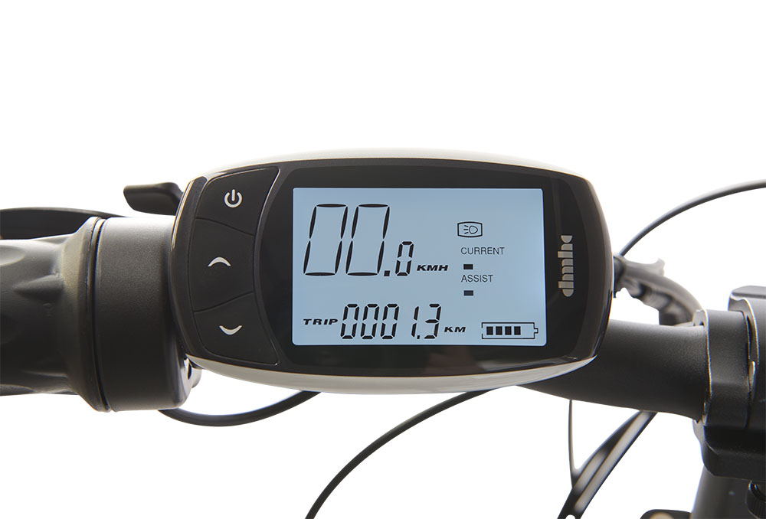  
Fig 1

The bike will be ready to ride and the LCD will activate showing battery state, assist level, time, trip and speed. Turning the pedals for more than ¼ of a revolution or twisting the throttle will now activate the motor.

2.1.9 To avoid unplanned acceleration, always make sure that the LCD assist level is set to 0 when mounting, dismounting and turn the bike off when leaving it unattended.

To set the assist levels, toggle with the + and – buttons (see fig 1)

2.1.10 For full information regarding the LCD display please refer to separate hand book available from Amps Electric Bikes or your retailer.

2.1.11 Remember to validate your warranty by visiting www.wisperbikes.com/mywarranty and filling in your details.

## Before each use

It is important you check your bike prior to each time you use it. Checks should include the following: (If you do find any damage or problems, do not use the bike until the problem has been solved or you have had the faulty item checked by an electric bike mechanic or your retailer).

2.2.1 Check the tyres for any visible damage.

2.2.2 Check the tyre pressures.

2.2.3 Check for any loose nuts, bolts or fixings. Check all folding mechanism clamps are closed tight and locked.

2.2.4 Check the brake functions.

2.2.5 Check the electronic functions.

2.2.6 Check the reflectors are in place and the lights are working.

2.2.7 Check the battery for any visible signs of damage.

## Battery care

2.3.1 Your Wisper bike comes with a high quality lithium ion battery. All lithium batteries need to be looked after to ensure years of full use. The latest Wisper 575Wh batteries come with new technology installed to assist you in looking after your battery and will be dealt with separately. Following these easy steps will ensure the long life of your battery

2.3.2 Recharge your battery after every use if possible. Keeping your battery charged extends its life and your bike is always ready to go.

2.3.3 You do not have to “condition” your battery by charging and discharging before it’s first use. This was the case with old lithium ion technology but is not necessary on modern batteries

2.3.4 Never leave your battery completely discharged for more than 24 hours. Voltage dropping below minimum for any length of time will cause serious damage to your battery cells. *

2.3.5 Recharge your battery every month even if you are not using the bike. Most lithium Ion batteries will continue to discharge even when the bike and battery are turned off (see above). If your battery falls below minimum Voltage, it may not be recoverable. *

2.3.6 Do not expose the bicycle or battery pack to fire, heat sources, acid or alkaline substances.

2.3.7 When leaving your bicycle during hot weather, always leave in a shaded well ventilated area.

2.3.8 For best results, always recharge and store the battery at room temperature.

2.3.9 Before unloading the battery, make sure it is turned off and unload the battery using its handle.

2.3.10 Further information on user responsibilities and battery maintenance are included in the warranty section of this manual.

* The most common cause of battery failure the owner not keeping to points 4 and 5 above.  
 This is the most common reason for customers to need to replace batteries. This is particularly noticeable in the spring when customers are using their bike for the first time in the new year. We get most calls regarding failing batteries during this period.

**IMPORTANT  
If your battery is damaged due to your leaving it discharged, or not recharging when advised as per this manual your battery is not covered by our warranty.**

**Battery safety**

2.3.11 **i. Never leave a battery connected to the charger or mains power over-night.**

**ii. Never recharge a battery outside, in damp conditions or in temperatures less then 0 degrees centigrade.**

**iii. Never open a battery case, try and fix the battery or give it to any one other than a registered Wisper Stockist for maintenance. (Failure to comply will void the warranty)**

**iv. If a battery is, or appears to be damaged or overheating for any reason, do not use the bike and immediately return the battery to your retailer for advice and a safety check.**

**IMPORTANT  
 Ignoring any of the safety rules above could cause serious injury or fire.**

2.3.12 Wisper 575Wh Lithium Batteries

Bikes fitted with the latest Wisper long range batteries have extra features to help keep it in good health.

i. “Deep sleep” or “hibernation” mode.   
 Once recharged the new Wisper 575Wh battery does not need recharging for up to 6 months over the winter. We recommend the battery is recharged every 6 months. To put the battery into deep sleep mode simply press the LED button on the battery for 10 seconds. If the battery is below 29V, deep sleep will be activated automatically after 24 hours of non-use. The battery will automatically wake up when you turn your bike back on.

ii. Remote Control Service System (RCSS)  
 Using the very latest technology we can connect the new Wisper 575Wh battery and charger system directly to the battery manufacturer’s technical department’s computer. Software updates will be uploaded to the battery and charger and system diagnostics will take place. The battery manufacturer will make recommendations to resolve any issues. In some cases, fixes can be made remotely. All Wisper Stockists will be able to check the condition of both battery and charger. Information such as the charging history, battery capacity, etc. will be available on screen.

iii. Phone Charger  
 The socket on the battery used for connection to the RCSS can also be used to charge a mobile phone.

## Recharging your battery

2.4.1 Before charging, make sure the charger is turned off and connect your battery to the charger at the charging socket. Plug the charger into a mains socket and turn on the mains socket. A red lamp will light up on the charger indicate the battery is charging. When the red light turns green, the battery is fully charged. To optimize battery life, leave the charger connected for a further hour and then turn off the charger and disconnect it from the mains after charging. Always disconnect the charger from the mains before disconnecting the charger from the battery. It is possible that the battery will take up to twelve hours to charge on the first three charges.

2.4.2 When charging the battery, always do so in a well ventilated area.

2.4.3 Do not leave the charger connected to the mains when not in use.

## Water

2.5.1 Your electric bicycle is rain and splash proof and can be used in all weathers.

2.5.2 The electrical components of the bicycle, such as motor, battery, and controller, must not be submerged in water.

## Maintenance and adjustments

2.6.1 **IMPORTANT!**  Do not attempt to open the casings of the battery, motor or controller. It could be dangerous and all warrantees will become void. If you experience a problem, contact our service department or your Wisper retailer.

2.6.2 Wheel spokes should be checked after 300 miles of riding. Handlebar and saddle tubes should never be raised beyond the maximum permissible, indicated by a safety line around the tubes. The recommended torque (tightness) of crucial fixings is as follows:

Front axle nuts. 46N.m   
 Back axle nuts. 70N.m  
 Handlebar and stem clamp bolts. 12N.m  
 Handlebar stem expander bolt. 10N.m  
 Seat pillar clamp nut/bolt. 5-8N.m  
 Seat clamp nuts. 24N.m  
 Crank axle Allen bolts. 40N.m  
 Gear shifter nuts. 4N.m  
 Rear carrier nuts. 8N.m  
 Mudguard bracket nuts. 8N.m

Other general torque settings depend on the thread size. M4: 2.5-4.0N.m, M5: 4.0-6.0N.m, M6: 6.0-7.5N.m.

2.6.3 Your bike has a rear derailleur that will automatically tension your chain. However, if the chain becomes loose or frequently comes off the front chain-wheel, please seek advice from your Wisper dealer.

2.6.4 Brake levers should lock the wheels when compressed half way between their open position and touching the handle bars.

2.6.5 Warning: Handlebar hand grips or tube end plugs should be replaced if damaged, as bare tube ends can cause injury.

2.6.6 Front brake pads must be replaced if the pad material wears to less than 1mm.

**IMPORTANT! braking distances increase on wet or icy roads.**

2.6.7 Lubrication:

6.7.1. Lubricate all pivot points on the derailleur and chain with light oil or chain lube on a regular basis.

6.7.2 Once a year, have your Wisper dealer re-grease the headset bearings, front wheel bearings and pedal bearings.

2.6.8 Recommended tools for proper maintenance:

Torque wrench with lb/in or N/m gradations

2, 4, 5, 6, 8mm Allen wrenches

9, 10, 15 mm open-end spanners and 15mm box end spanner

14, 15, and 19mm socket

T25 Torque wrench

No. 1 Phillips head screwdriver, bicycle tube patch kit and tyre pump

## Technical specifications & performance

**Motor** Brushless, 250W hi torque brushless rear wheel drive.

**Battery** Lithium with advanced battery management system (BMS)

Medium range 375Wh 2.6kg

Long range Samsung 575Wh 3.4kg

Both batteries use identical battery cases so are interchangeable between

705, 806 or 905 Wisper bikes

Remote Control Service System (RCSS) on 575Wh only

Deep sleep mode. Protects battery during times of non-use on 575Wh only

**Battery case** Polycarbonate/ABS mix, non conductive for extra safety, conforms to

2013 90cm drop test.

**Mains charger** Lithium 42V output intelligent charger communicates with battery

management system (BMS), auto stop when fully charged

2A, Charge time 2.5 to 8hours depending on battery state

**Connections** All electronic components and motor wheel have individual connectors for

ease of servicing

**Assisted range** 375Wh battery Average 30miles/80kilometers Max 70miles/115kilometers

575Wh battery Average 50miles/115kilometers Max100miles/150kilometers

**Assistance** 1. Throttle only: to 4mph/6kph

2. Throttle assist: complete throttle use when pedaling forward

3. Pedelec: with 4 levels of assistance power and safe mode

4. Twist throttle to 4mpoh or 15.5mph when pedals are turning forward.

**Max speed** 15.5mph/25kph with powered assistance

**Controls** Back lit LCD display panel with bike and light on/off switch

Power assistance: five levels

Speedo, Range, Trip, Battery state, Clock

**Bicycle weight** 18.5kg without battery

Including battery and all accessories

375Wh: 21kg

575Wh: 22kg

With optional suspension forks add 1kg

**Load capacity** 135kg/290lb/20st 9lb

**Frame** Hand welded,6061 Alloy T4 and T6 tempered

**Frame size** 20” 50cm

**Finish** Stealth Black Silk painted and lacquered, three stage oven hardened

**Forks** Wisper light weight forks

**Seat post** 400mm black anodised aluminium

**Saddle** Wisper Comfort E-Bike Saddle

**Handlebars** Black anodised alloy with ergo support grips

**Stem** Black anodised alloy adjustable height

**Kick stand** Black anodised alloy

**Gears** SHIMANO 7 speed derailleur with 7 speed selector

7 speed Shimano rear sprocket

**Chain ring** 170mm 52 tooth

**Chain guard** Full, alloy Stealth Black paintwork

**Chain** KMC Z51RB rust resistant

**Cranks** Anodised Black alloy

**Drop outs** Stainless steel cassette

**Main Bearing** Sealed bearing

**Pedals** Wellgo city and touring style alloy non-slip, sealed bearings

**Brakes** Tektro 160mm disc brakes front, V brakes rear

**Rims** Alloy double walled 20” x 1.5”

**Spokes** 13g black anodised

**Tyres** Kenda 20” 1.95 high puncture resistance with Kevlar and wall reflector

**Mudguards** Polycarbonate shatterproof

**Lighting** Front: 36V 15W LED, power from bike e-system

Rear: 36V light, power from bike e-system

Reflectors: front white, rear red, wheels orange and pedal reflectors

**Rear Rack** Certified to 25kg   
 **Metal fixings** A4 grade stainless steel or alloy

## Simple Trouble shooting

|  |  |  |
| --- | --- | --- |
| Problem | Possible reason | Solution |
| Top speed too slow | 1. Low battery voltage  2. Handlebar control problem  3. Damage to motor driveline | 1. Recharge battery fully  2. Call service  3. Call service |
| Power on, but motor not working | 1. Battery not connected  2. Motor connection damaged  3. Handlebar control problem | 1. Re install battery  2. Call service  3. Call service |
| Low range after recharging the battery | 1. Tyre pressures too low  2. Undercharge or charger fault  3. Battery capacity loss or damage  4. Hill climbing, frequent stops, strong headwinds, overloading. | 1. Check pressures  2. Recharge completely or have charger inspected  3. Replace battery |

# Controls and equipment

In this section, the functions and any specific maintenance needed on all the main controls and ancillary equipment are described.

## Battery on/off switch and lock

3.1.1 Your Wisper bike is supplied with two identical keys. The key locks the battery to the bike.

3.1.2 The battery is connected to the electrical system of the bike automatically when you slide the battery into the rack. To turn on the bike’s electrical system, press 1 on the switch located on the right hand side at the rear of the battery. To turn off the power, press 0.

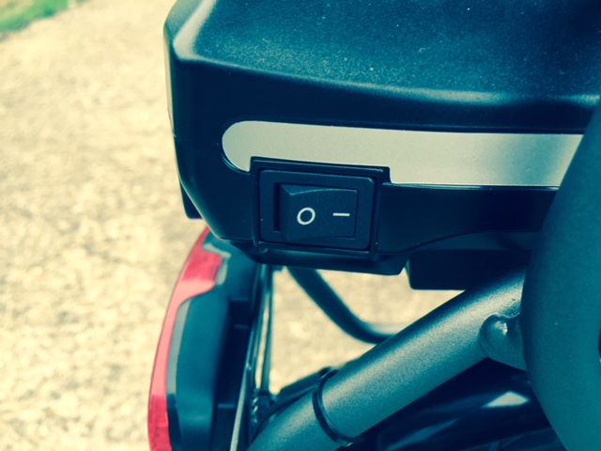  
 Fig 2

3.1.3 When the battery has been turned on, the bike is now ready for use. The on/off button on (the top button c- on the handle bar control) isolates the power from the bike.

When the on/off button is pressed for 3 seconds the LCD symbols will become visible. When the on/off button is pushed again for 3 seconds, the LCD symbols will disappear - you have turned the bike “off”. When the bike is “off” you will not get any assistance from the battery and motor and the bike is effectively an unpowered pushbike.

3.1.4 To lock the battery into the bike frame, slide the battery into the battery holder in the rack until you hear a click. To unlock the battery, turn the key fully anticlockwise and hold in this position whilst siding the battery out.

3.1.5 The battery can be charged either on or off the bike.

## The ON/OFF button and Light button

3.2.1 To turn the power on so the pedelec system is operational, simply press the on/off button (marked with a c-) on the handle bar control for 3 seconds - the LCD symbols will become visible showing the power is on. When the on/off button is pushed again for 3 seconds and the LCD symbols become invisible you have turned the bike “off”. When the bike is “off” you will not get any assistance from the battery and motor and the bike is effectively an unpowered pushbike. If the bike is left for ten minutes without being ridden, the bike will automatically turn off. The battery capacity indicator lights provide an indication of the battery capacity remaining with four bars indicating the battery is at full capacity. The display also incorporates a diagnostic function.

3.2.2 The LIGHT button is the on/off, C- button found on the LCD. If you press when the bike’s power is on, the LED headlight and rear light will illuminate. The LCD display will also become back lit. Press it again to switch off the lights. The power for the lights comes from the bike battery, but due to the low power consumption of the LED lights, you will not noticeably reduce your range.

## The Throttle

3.3.1 The twist grip throttle can be found on the left hand side of the handlebars. Further details of the operation are provided below. The twist and go throttle has two functions:

i. To power the bike sufficiently to help when walking the bike to a maximum of 4mph 6km/h. This can also be achieved by pushing the – button for 3 seconds and holding.

ii, To increase the power to the motor when pedaling the bike.

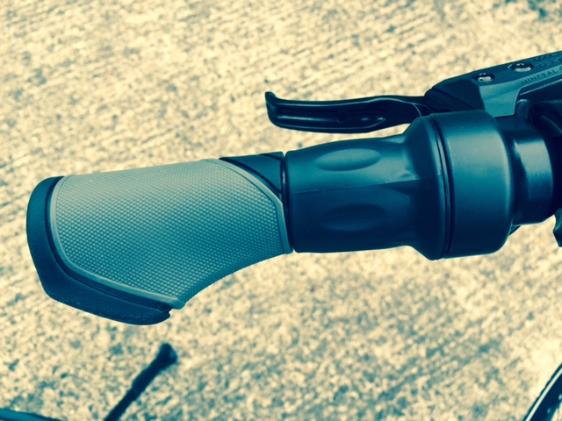

## Pedal assist power

3.4.1 When you first ride your Wisper bike, you will notice that the motor will start working when you have turned the pedals through between 90 and 180 degrees.

3.4.2 You will find the assist buttons (marked with up and down arrows) on the handle bar control. Each time the UP button is pressed, the LCD will move between 1 and 5 levels and the corresponding power level increases in increments of 25%. Setting 5 provides 100% power. The default level is set to 1 when the bike is first turned on. We recommend that you only turn on the bike after you have mounted the bike so the motor is deactivated. Once on the bike, press the on button for three seconds and the assistance will be turned on. You can start off in any level, if you are on a hill for instance you may want to start in level 2,3,4 or even 5.

3.4.3 Setting 5 is generally used when you need the maximum amount of assistance from the motor, but this will drain the battery the fastest. Lower settings are used when you do not need the assistance at 100% power. In high traffic situations or poor conditions such as ice and snow, instant full power could be dangerous. Power settings can be changed when the bike is stationary or when on the move.

**IMPORTANT! Make sure your throttle and handlebar grips are always intact and in good condition. Uncovered handlebar tubes can be very dangerous.**

## Battery capacity meter, riding style and affect on range

3.5.1 The range of the bike (distance covered between recharging of the battery) is greatly influenced by the level of assist selected, the amount of pedal assistance provided by the rider and the use of the throttle.

3.5.2 If a high level of assist is selected, then the range of the bike will be reduced compared to using a lower level of assist.

3.5.3 The Wisper cadence sensor system detects the speed the pedal cranks are turning and the This information is fed into an on board computer (controller) to give the rider the most natural riding experience possible.

3.5.4 The optimum range is achieved when the rider pedal effort is maximized and an ideal situation is for the rider to aim to match the power being provided by the bike on an equal basis.

3.5.5 The battery capacity indicator is provided to give an approximation of battery capacity remaining. Each bar on the LCD approximates to a ¼ of the capacity. However, this indicator relies on sensing battery voltage that will rise and fall depending on the amount of power being demanded at any given time, ambient temperatures etc, hence the meter should only be used for indication purposes.

3.5.6 The battery capacity indicator, built into the top of the battery (four LEDs) provides a similar indication and operates on the same principle.

3.5.7 Under heavy power situations (full throttle or high levels of assist) the battery voltage will temporarily dip resulting in the capacity meter showing a lower level of charge. When the heavy power usage is reduced, the capacity meter will rise again as the battery naturally recovers its voltage.

3.5.8 During the discharge period of the battery, the voltage will drop from an initial voltage of nearly 42 Volts to a minimum of 31.5 Volts. The bulk of the discharge period will be in the range of 38 to 36 Volts which provides the optimum performance for the bicycle. Hence due to this wide range in voltage, the performance of the bike will vary depending on the state of charge of the battery. To achieve the best possible performance, it is better to start a journey with a fully charged battery and to recharge it at the end of each journey.

## Brakes

3.6.1 Disc brakes are fitted to the front and V brakes to the rear wheels of the bicycle. Disc brakes offer several advantages over traditional rim brakes, including better braking in wet, muddy or other adverse conditions and less braking power fade over extended downhill braking.

3.6.2 Details of how to adjust and maintain your brakes are as follows:

3.6.3 Regularly inspect the brake pads for wear. If the front brake pads have reached the wear limit of 1mm, replace them immediately. The rear brake blocks should be checked by a bicycle mechanic and replaced when necessary.

3.6.4 Front brake, remove the caliper from the fork leg, complete with the mount adapter by removing the two 6mm Allen caliper fixing screws. The pads can then be removed by unscrewing and removing the pad retaining screw (which passes through the tabs of the brake pads) using a 3mm Allen wrench. Then lift the pads complete with the spring out of the rotor slot in the caliper body.

**Warning!** Do not loosen any other screws on the caliper.

3.6.5 To refit the pads, hold the pads complete with spring as an assembly and insert into the caliper slot with the metal backing towards the pistons. Refit the pad retaining screw ensuring it passes through the holes in the pad tabs and through the hole in the spring and tighten to 3– 5 N.m. Refit the caliper loosely using the two Allen screws, apply the brake lever and tighten securely to 6 to 8N.m whilst continuing to apply the brake lever. (N.B. use of a thread locking compound is recommended on the caliper fixing screws).

**Warning:** If you are unsure about any part of the brake installation process you should seek advice from a Wisper service center or qualified mechanic.

**Caution:** The pads and rotor must be kept clean and free from oil or grease based contamination. If the pads become contaminated, you must discard them and replace them with a new set. A contaminated disc should be cleaned with a proprietary brake cleaning solution.

## Stem and handle bar clamps

3.7.1 Your bike has been fitted with an adjustable handlebar and stem clamp that allows you to change the angle and height of the bars to find the most comfortable riding position.

3.7.2 The handlebars can be adjusted before you use the bike by slackening the clamp in the middle of the handle bars. Once a comfortable position is achieved, securely tighten the clamp and lock into position.

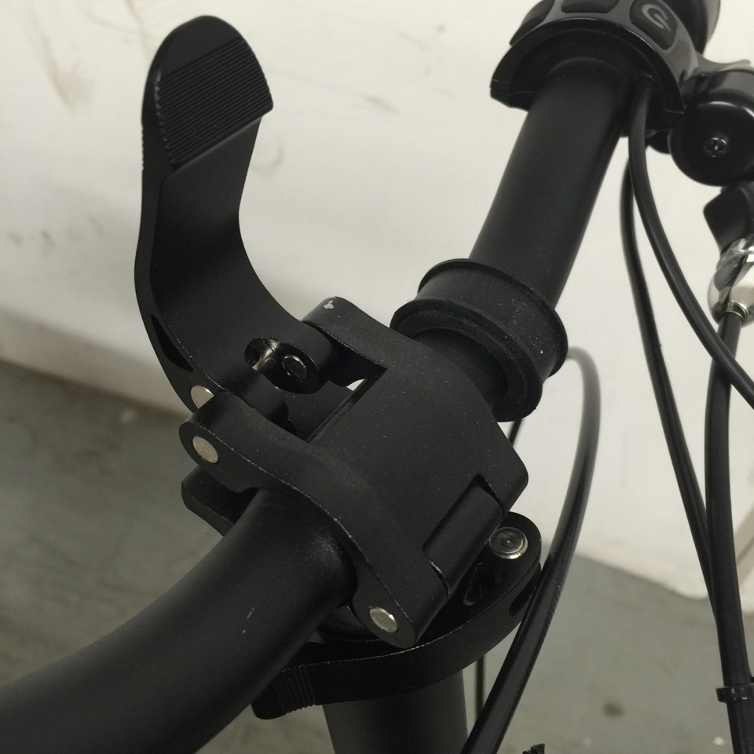 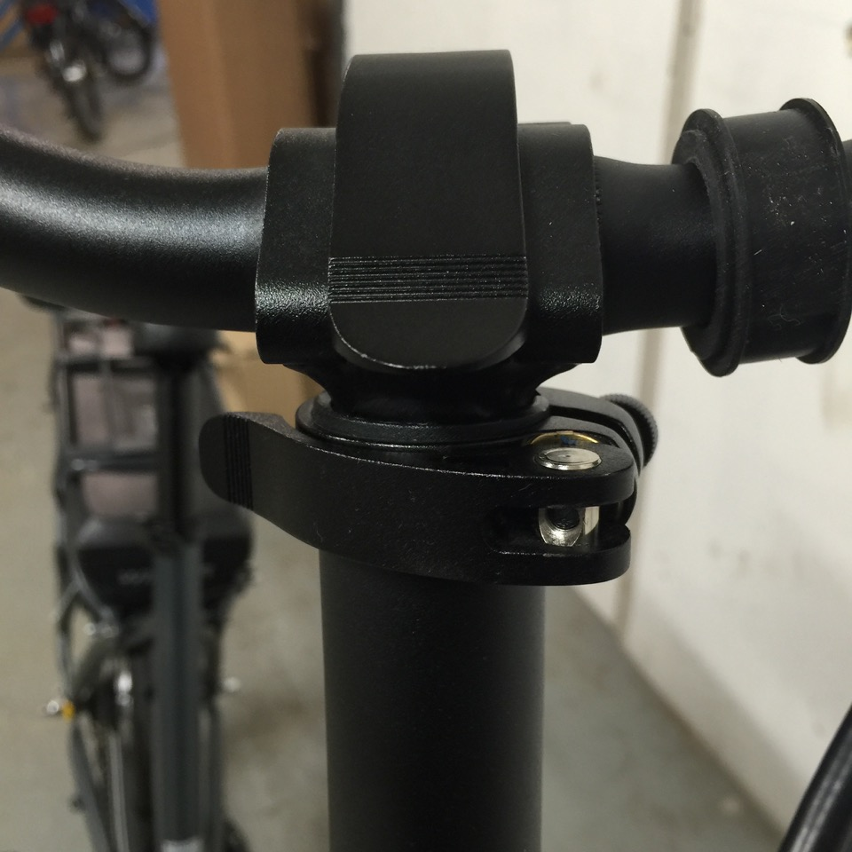

3.7.3 To alter the height of the handle bars, slacken clamp at the front of the stem. Slide the handle bars to the requires position and securely clamp into position making sure there is no movement in the clamp or handle bar stem.

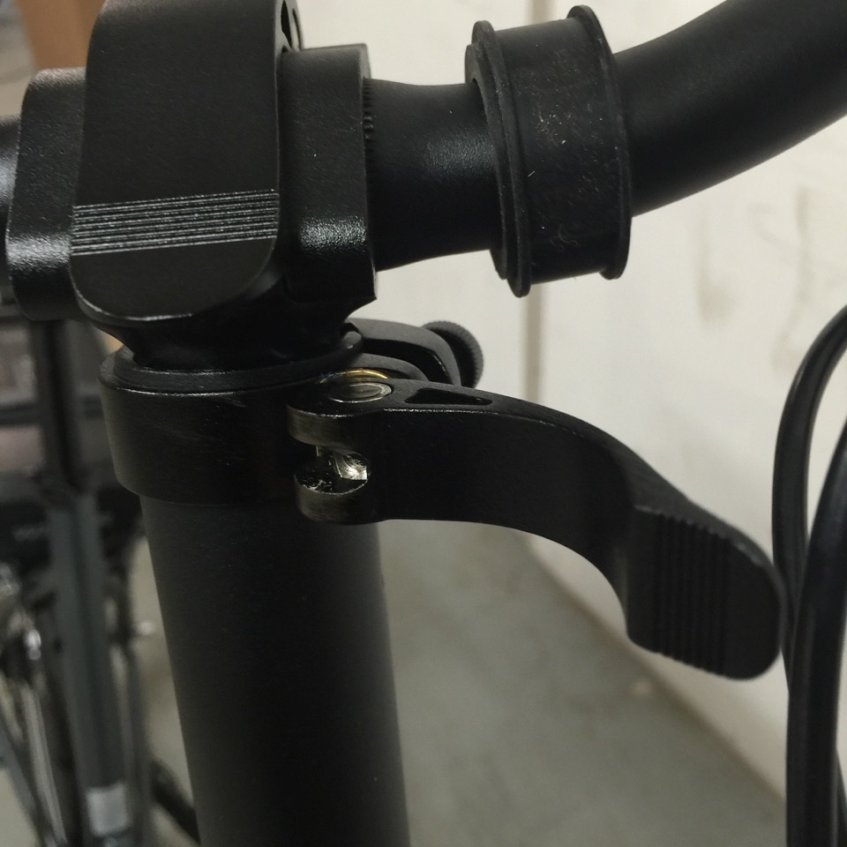 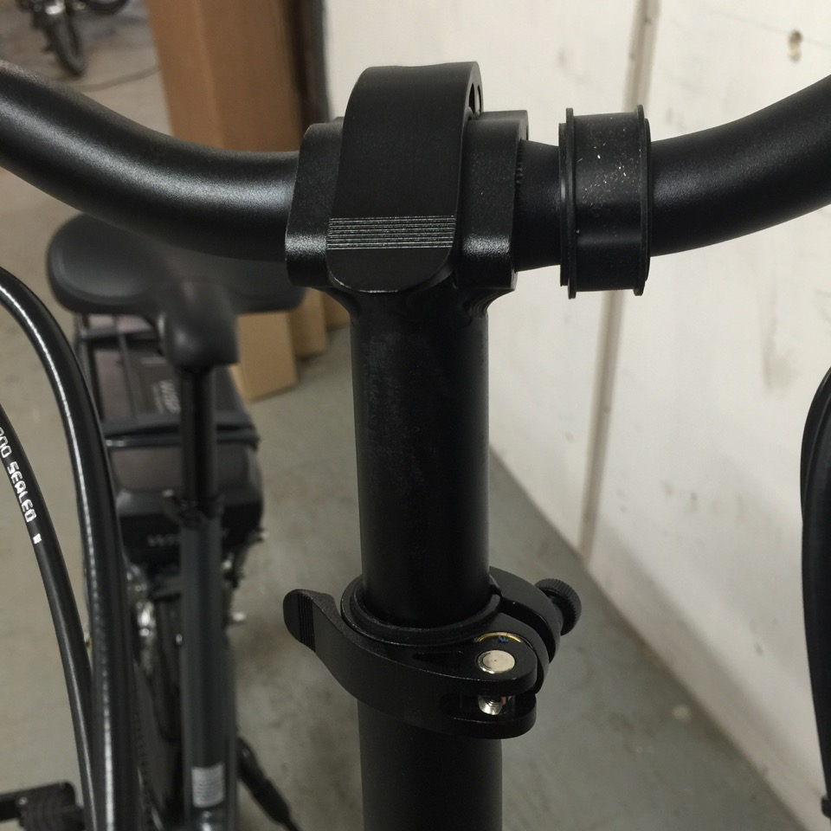

## Folding Mechanism

### Your Wisper folding bike has been fitted with ultra strong clamps to enable you to fold the frame and handle bar stem. It is vitally important that these clamps are tight, secure and locked before using the bike.

### The Stem clamp has a chromed locking mechanism. To unclamp the stem, slide the chromed locking knob up towards the handle bars and pull the lever away from the stem, the stem will now fold away from the clamp. When unfolding the stem make sure the clamp is solid against the stem, the chromed locking knob is pushed back up into position and the clamp is locked.

3.8.3 The main frame clamp

To unclamp, first turn the black plastic lock into the upright unlocked position. Then pull the clamp arm forward, unhitch the catch and push the clamp arm forward again. Finally fold the bike away from the clamp arm. To unfold repeat the same procedure in reverse, making sure you do not trap the cables inside the frame in the clamp.

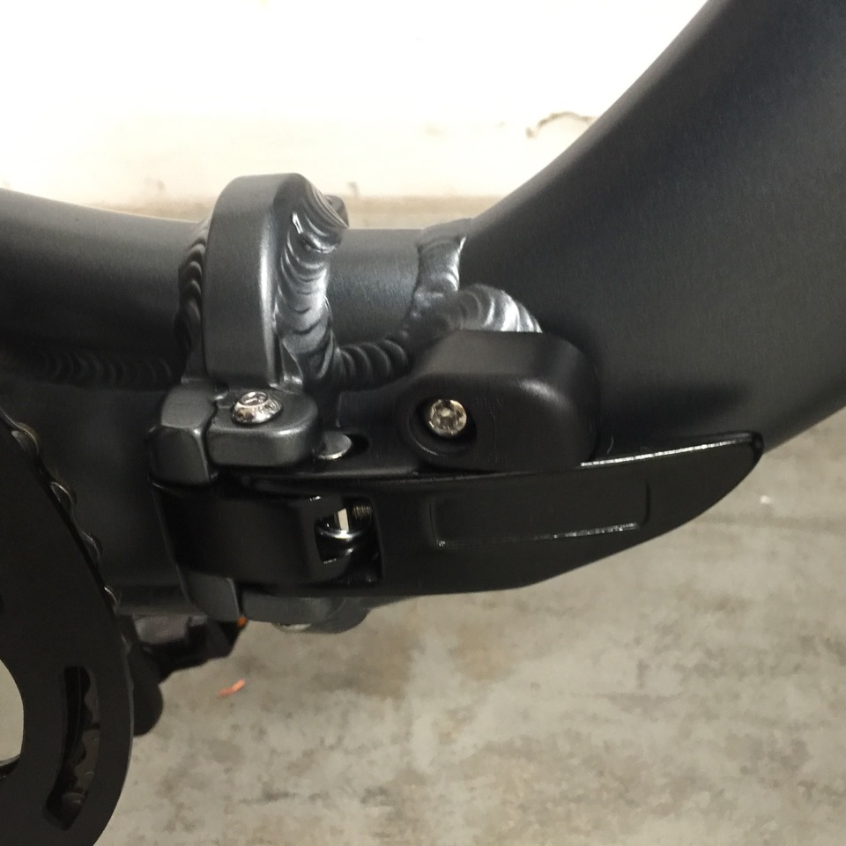 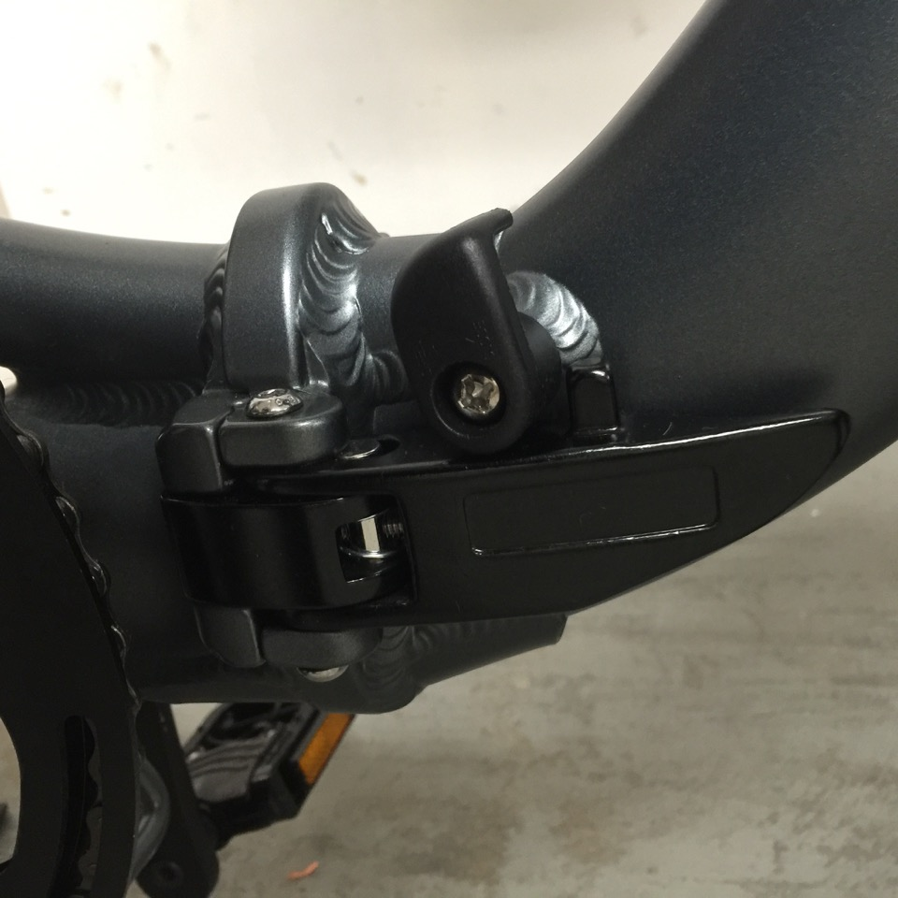

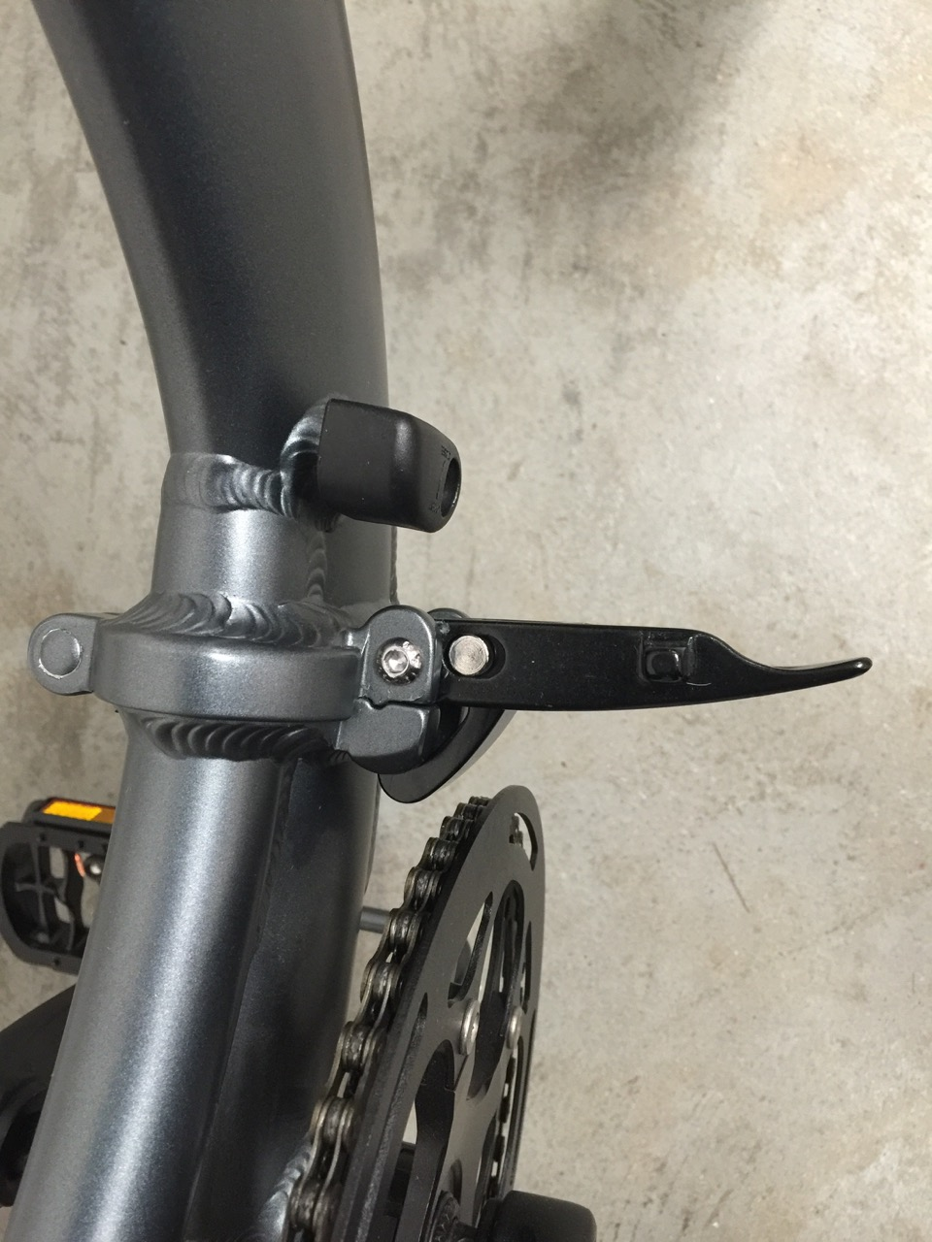 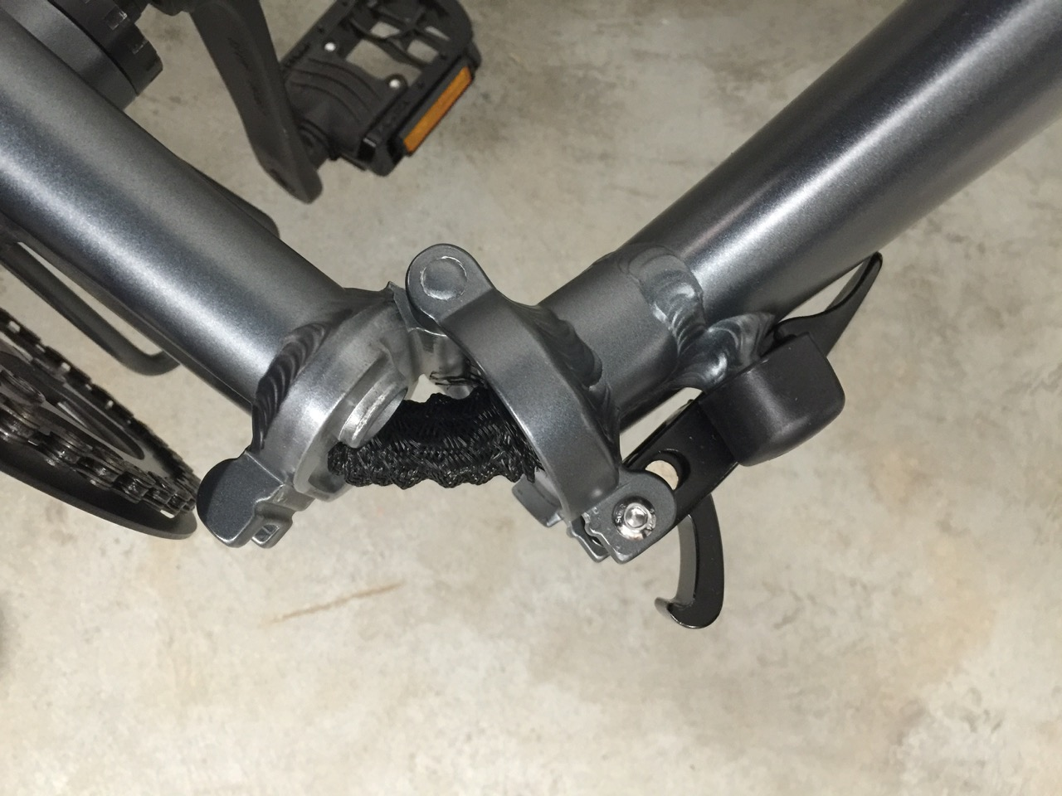

3.8.4 Folding the pedals is very straight forward.

Simply push the pedal in towards the bike with your hand or foot and fold down. To unfold lift the pedal back to its normal position. Make sure it has located properly.

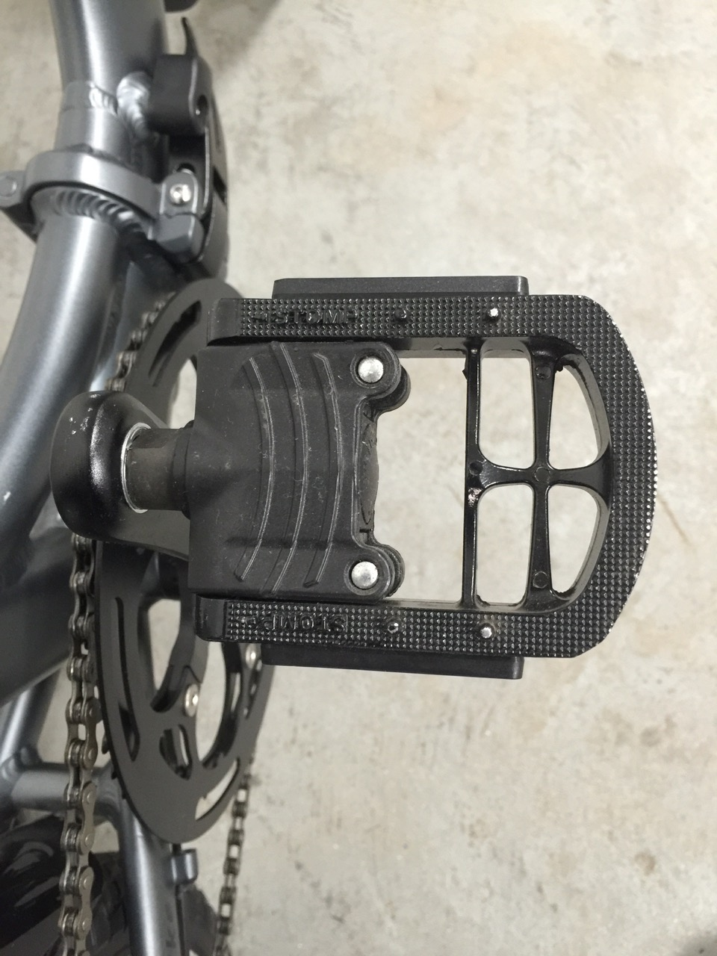 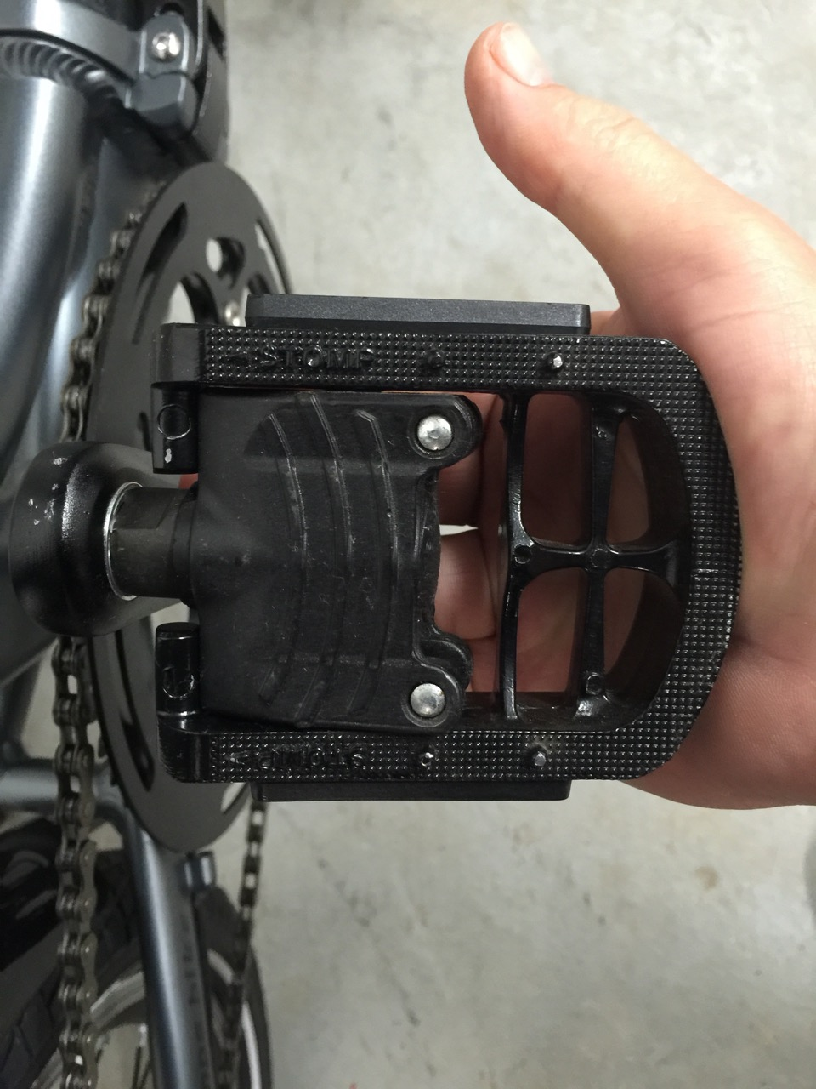

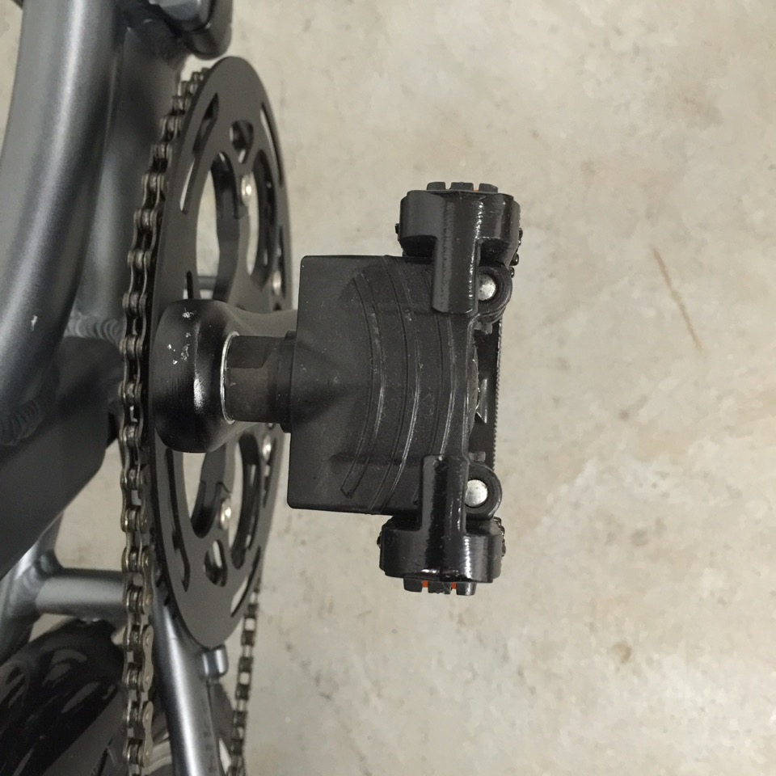

## The connectors

3.9.1 All electronic components have individual connectors, this allows for the easy removal for diagnosis, repair or replacement of any of the electronic parts. The connectors, being a push fit are simple to disconnect or reconnect and click into position when fully engaged. Each connector has a different number of pins and an alignment arrow, so it is important to ensure the connectors are only mated in their original positions, damage may occur to the pins if this procedure is not followed.

## Quick release saddle height adjustment

3.10.1 Your Wisper bike has been fitted with a quick release saddle post fitting to facilitate the movement of the saddle height.

3.10.2 It is important that the knurled nut on the fitting is tightened so the post will not move in the bike tube. Make this adjustment with the quick release lever in the open position.

3.10.3 Adjust the seat to the correct height and close the lever firmly. When you sit on the saddle there should be no vertical movement at all in the saddle post beyond the seat post suspension movement. Never apply grease to the saddle post.

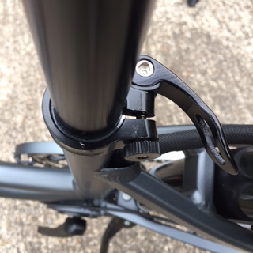

## Rims and spokes

3.11.1 It is essential to have your spokes checked and tightened after 300 miles. This is a free service provided by your supplier. If this service has not been undertaken at the correct time, this may cause damage to the wheels and spokes that will not be covered under our Warranty.

## Chain and drive wheel removal

3.12.1 To completely remove the rear wheel, it is necessary to disconnect the main motor cable connecting the motor to the bicycle electrical system. This operation is best achieved by turning the bicycle upside down.

3.12.2 Locate the motor cable where it emerges from the centre of the wheel axle on the left hand side of the bicycle, slide back the top hat protector to locate wheel nut.

3.12.3 Trace the route of the motor cable along the rear stays and locate the quick release motor cable connector shown in the image above. Disconnect the two halves of the connector, taking care not to strain the cables, and unclip the motor cable from the frame. Note the alignment marks on the two halves of the connector.

3.12.5 Loosen the two large motor axle nuts and remove the nut from the right hand side, taking care to note the position of any tab washers fitted. Unscrew the left hand nut as far as is possible towards the cable exit from the motor axle, being careful not to damage the cable.

3.12.6 Lift the wheel from the frame dropouts, being careful not to snag or strain the motor cable.

3.12.7 Installation is the reverse of the above. Take care to locate the tab washers correctly in the drop out slots and tighten the axle nuts to the torque specified in the manual. Reconnect the two halves of the quick release connectors, taking care to ensure the pins and alignment arrows align correctly. Re-clip the cable to the frame, ensuring that the cable cannot rub against the tyre and that the cable exits in a downwards direction from the axle to avoid water ingress into the motor. Refit the rubber top hat cover.

Because the bicycle has a rear derailleur, the chain will be automatically adjusted.

## Derailleur and gear change

3.13.1 Full details on how to adjust and maintain your derailleur can be found in the Shimano manual.

If difficulty is experienced with changing gear after initial operation of the bicycle, it is likely that some cable stretch will have occurred in the gear change cable. To compensate for this turn the knurled adjuster shown in the centre left hand side of the image below by pulling it away from the outer cable stop in the direction of the cable towards the rear of the bicycle and turning it ½ turn anticlockwise when viewed from the rear. This will compensate for the cable stretch. If necessary, repeat the operation again until smooth gear selection is obtained or return your bicycle to your Wisper dealer for further adjustment.

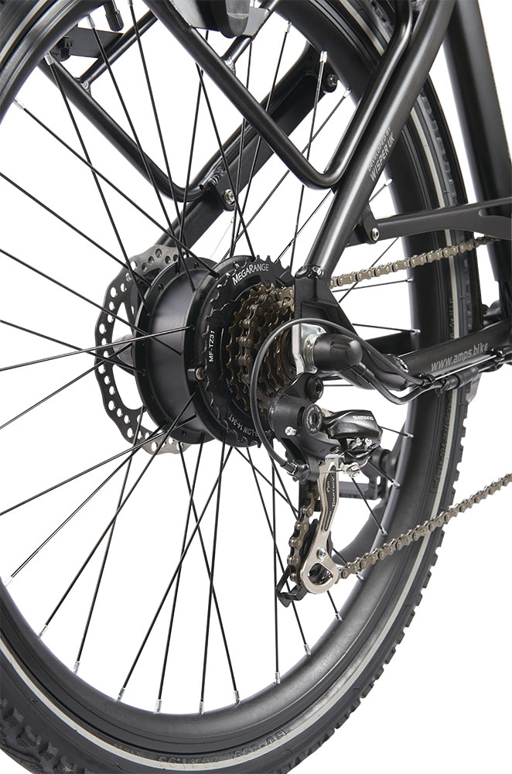

3.13.2 To change gear, use the 7 speed rapid fire gear shifter located on the right side of the handlebar. The two levers located underneath the shifter can be pulled and pushed to select the gears over the range 1 to 8.

# Warranty, battery maintenance and user responsibilities

**Repair or replacement of components**

**IMPORTANT!** To validate this warranty, the retail customer must register the bike at www.amps.bike within 14 days of purchase.

Only use this product in accordance with this user manual. Wisper offer a limited warranty on the following items.

|  |  |
| --- | --- |
| Main frame | Ten years |
| **Motor shell, Hub motor, Controller and Charger** | Two years |
| **Electronic handle bar controls and electrical connections** | Two years |
| Paintwork (excluding accidental or deliberate damage) | Two years |
| **Battery capacity loss of more than 30%** | Two years |
| **Lights and lighting system** | One year |
| **All other parts, other than consumables not shown above** | One year |

**Terms and conditions**

|  |  |
| --- | --- |
| 1. | If the product has a quality fault within 15 days of delivery, the part will be repaired or replaced or in exceptional circumstances we may replace the whole vehicle. |
| 2. | The period of assurance shall commence from the day delivery was made to the retail customer, or from the day the retail customer collected the bike from the retailer. |
| 3. | To validate this warranty, the retail customer must register their bike within 14 days of purchase. |

**Exceptions to Limited Warranties**  
Your Wisper bike may not be covered by our warranty for any of the following reasons:

|  |  |
| --- | --- |
| 1. | Damage resulting from misuse, not maintaining the vehicle or not following the guidelines within our user guide or using the vehicle for any kind of competitive sport. |
| 2. | Accidental or deliberate damage. |
| 3. | Damage due to private repair or alteration by user or unauthorised service centre. |
| 4. | Failure to produce invoice or proof of purchase. |
| 5. | Spare parts and components worn in normal use. |
| 6. | Failure to register bike within 14 days of purchase. |
| 7. | Failure to have your bike safety checked and the spokes tightened within 300 miles or three months of purchase. |

## Battery maintenance and user responsibilities

4.1.1 Your Wisper bike is equipped with a powerful, high quality lithium ion battery. Lithium ion is recognised as being the very best type of battery for electric bicycle use.

4.1.2 All lithium ion batteries must be well cared for to optimise useful life and range. It is the responsibility of the bike owner/operator to ensure the battery is looked after properly. Incorrect use or storage of your battery may cause damage and void your warranty.

4.1.3 It is not unusual for a well-maintained battery to last for several years. Though your bike will feel less powerful as the battery gets older, and the range will diminish, you can continue using the battery for many years to come.

A key point to remember when choosing a battery is to check the battery capacity (V x Ah = Wh the battery’s capacity) i.e.16Ah x 36V = 576Wh. When such a battery loses 30% of its capacity, it will still have nearly 400Wh left, still more than a new 36V 10Ah (378Wh) battery. Choosing a larger battery not only gives you more power and range, but is often more economical in the long term.

4.1.4 The key to having a long lasting battery is to look after it. This means never leaving your battery fully discharged and always conditioning the battery when not in use i.e. in the winter.

4.1.5 If a battery is not cared for as per our instructions, it will not reach its optimum performance and may not be covered by our warranty.

**We reserve the right to check batteries claimed under warranty to ensure they have been maintained as per our instructions.**

# Service

After sales service is available through your retailer. If you are unable to contact your retailer, please contact our Wisper Support team support@amps.bike

Amps Electric Bicycles Ltd  
Unit A7  
Watery Lane  
Kemsing  
Kent  
TN15 6PW

support@amps.bike

www.amps.bike

Copyright May 2017 Amps Electric Bikes Ltd

# Pre Delivery Inspection check list

The PDI is a critical part of the overall Quality Assurance process and must be completed by the supplying dealer followed by a test ride and sign off before passing the bike to the customer.

The following items below are a generic list for all current Wisper models and must be covered during the PDI.

|  |  |  |
| --- | --- | --- |
| **Item Check off by No.** | **Activity Mechanical Parts** | **Notes** |
| 1 | Check front and rear wheel for alignment and run out | Tighten spokes if necessary |
| 2 | Check tightness of rear axle nuts and front quick release | Tighten to torque setting in user manual |
| 4 | Check tyre pressures front and rear | Inflate to correct pressure |
| 5 | Check and adjust action of front and rear brakes | Ensure there is no noise or squeal |
| 6 | Check smooth action and adjustment of front suspension forks |  |
| 7 | Check adjustment of bearings in headstock | Adjust if necessary |
| 8 | Check security of all handlebar stem fixings and clamps | Adjust to suit customer preferences |
| 9 | Check front and rear mudguards for security and clearance from tyres |  |
| 10 | Check all cables are clipped securely and safely | Check motor cable cannot rub against the tyre |
| 12 | Check pedals have been fitted correctly and tightened fully | Note left and right hand threads |
| 13 | Check pedal cranks have been tightened fully on bottom bracket axle. | Tighten to torque setting in user and service manual |
| 14 | Check smoothness and running clearance of bottom bracket |  |
| 15 | Check seat post quick release clamp is properly in place and secure and saddle is correctly fitted. | Adjust as necessary |
| 16 | Check smooth operation of gear change on either derailleur or hub gear and ensure all gears can be selected | Adjust as necessary |
| 17 | Ensure side stand supports bike correctly and does not interfere with other moving cycle parts |  |
| 18 | Ensure motor wheel turns smoothly and quietly when rotated by hand in forward and reverse direction | Some additional resistance will be felt when rotated in reverse |
| 19 | Ensure correct chain tension |  |
| 20 | Ensure chain guard is not rubbing on models equipped with guard |  |
| 21 | Ensure all reflectors are in place on pedals, wheels etc |  |
|  | **Electrical Parts** |  |
| 1 | Fit and check correct operation of front and rear lights |  |
| 2 | Check connections for installed components |  |
| 3 | Check throttle returns smoothly to closed position | Adjust if necessary |
| 5 | Check functionality of LCD display | Includes selection of five power assist levels, speed readout, and all functions are correct as described in the user manual |
| 7 | Check battery locates properly and locks in place securely | Ensure keys are present |
| 10 | Charge battery off the bike and check charger and battery functions correctly | Check status lights on battery |
|  | **Road Test** |  |
| 1 | Road test the bike in a safe environment to test functionality of both electrical and cycle systems as described in the user manual - check noise and performance levels | Adjust / correct after test ride. |
| 2 | Notify Amps support if any manufacturing faults are identified, providing photographs if possible of any faulty components. |  |
| 3 | Run through the bike operation, battery charging and storage instructions and offer safety advice to the customer |  |

Copyright May 2017 Amps Electric Bikes Ltd